Y2Q2W2

Hezekiah

Ask: Have you ever noticed how the sun moves during the day?

Ask: Do you know what a sundial is?

Demonstrate: A sundial using a torch.

Say: Today we are learning about a day when something special happened with a sundial.

Bible Story – With magnet book

Sing Songs

Return to tables
Memory Verse: Fill in the blanks and then say the memory verse on the colouring page.

Primary / Junior / Teen: This term, those of you who would like to get a Bible to take home, may take one of the orange Commandment pages and add to your book. Each week you come you can put a sticker on it and when it is all complete we will get you a Bible to take home and keep.

Say: This term we are going to make fridge magnets to tell the Bible stories with. You will keep your magnets in a special magnet book which we will loan to you until the end of the term and then you can take the magnets home – but we will keep the magnet books for next time. DO NOT DRAW OR WRITE ON THE MAGNET BOOKS

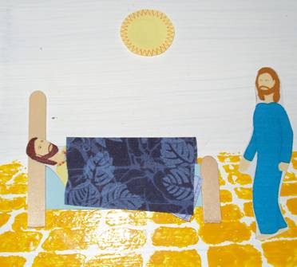
Magnet Books
- If they were away last week: Choose a magnet book. Write your name on a label and loop through handle. Hand out king and crown.
- Make a bed by taping two pieces of paddle-pop to a cardboard "mattress" and add a material cover and magnets on the back.
- Stick a magnet on a sun.
- Hand out the prophet.

Discuss the following depending on age, interest and time:
How powerful is God?
If God can make the sun go backwards, is there anything in this world He cannot do?
Why does God not do things sometimes? (He lets people choose. Sin makes bad things happen.)
Do you think many people would notice if the sun went backwards today?
It was a great opportunity for Hezekiah to tell other nations about God. Did he do it? Read 2 Kings 20:12-16
Was Hezekiah a good witness to the visitors from Babylon?
Are you a good witness?

Ask: If God can move the sun backwards, what else can He do?

Read: A story about God doing something amazing.

Optional 2nd Craft Those who would like to may make a sundial.

Say: This term we are going to see what we can do to make our church a nicer place. Each table will choose something special. If you have any ideas what you would like to do then talk to your teacher.

Finish with prayer.

